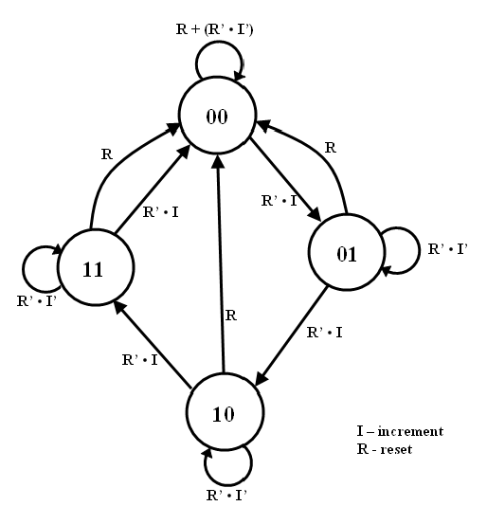

|  |  |  |  |  |
| --- | --- | --- | --- | --- |
| I | Q1 | Q0 | Q1+ | Q0+ |
| 0 | 0 | 0 | 0 | 0 |
| 0 | 0 | 1 | 0 | 1 |
| 0 | 1 | 0 | 1 | 0 |
| 0 | 1 | 1 | 1 | 1 |
| 1 | 0 | 0 | 0 | 1 |
| 1 | 0 | 1 | 1 | 0 |
| 1 | 1 | 0 | 1 | 1 |
| 1 | 1 | 1 | 0 | 0 |

|  |  |  |  |
| --- | --- | --- | --- |
| Q1+ | inc |  |  |
| Q1Q0 |  | 0 | 1 |
|  | 00 | 0 | 0 |
|  | 01 | 0 | 1 |
|  | 11 | 1 | 0 |
|  | 10 | 1 | 1 |
| Q0+ | inc |  |  |
| Q1Q0 |  | 0 | 1 |
|  | 00 | 0 | 1 |
|  | 01 | 1 | 0 |
|  | 11 | 1 | 0 |
|  | 10 | 0 | 1 |

Q1+ = (Q1’Q0) + (I’Q1) + (IQ1’Q0)

Q0+ = (I’Q0) + (IQ0’)

MOD4:

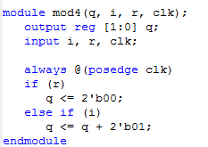

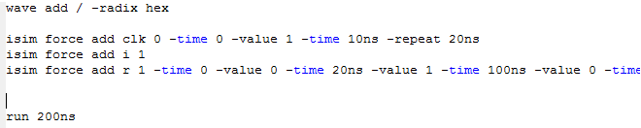

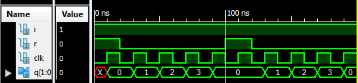

Programmable Timer:

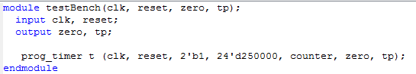





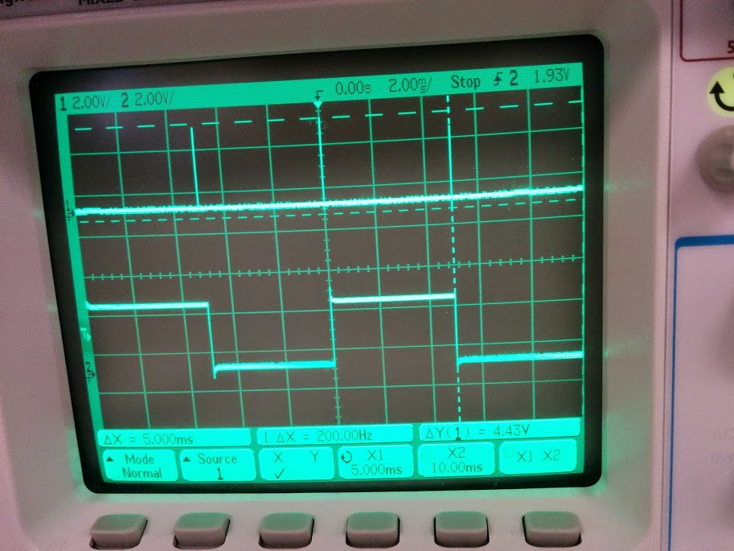

4x7 & Test Bench:

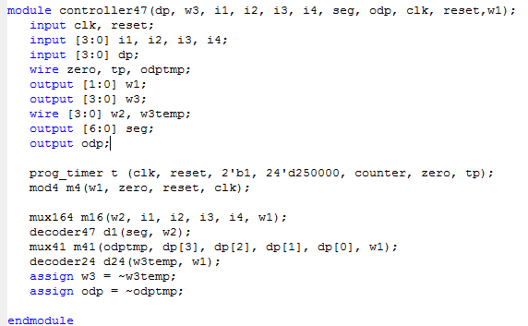

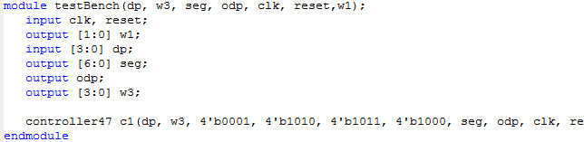

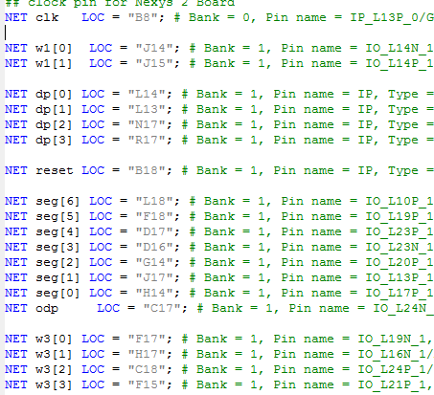

Anomalies:

I had my segments in reverse order which was a really confusing bug.